AI POWERED SMART EV CHARGING

FINAL YEAR PROJECT REPORT

Submitted

by

Nitin Kumar

in partial fulfilment for the award of the degree

of

BACHELOR OF TECHNOLOGY

IN
COMPUTER SCIENCE AND ENGINEERING

AT


SCHOOL OF ENGINEERING, DESIGN AND AUTOMATION

DEPARTMENT OF COMPUTER SCIENCE AND ENGINEERING

(2022-2026)

January – June 2026

CANDIDATE'S DECLARATION

I hereby certify that the work which is being presented in the Industrial Training project report entitled “AI-POWERED SMART EV CHARGING” by “Nitin Kumar” of Batch 2022-2026 in partial fulfilment of requirements for the award of degree of B.Tech. (CSE) submitted in the Department of Computer Science and Engineering at GNA University, Phagwara is an authentic record of my own work carried out during a period from January 2026 to June 2026.

Signature of Student

Nitin Kumar

(GU-2022-4243)

B.TECH CSE 8A

This is to certify that the above statement made by the candidate is correct to the best of my/our knowledge.

Signature of Internal Examiner(s)

The B.Tech Viva –Voice Examination of (Nitin Kumar) has been held on 16 July 2026 and
accepted.

Signature of External Examiner

Signature of H.O.D



ACKNOWLEDGEMENT

We would like to place on record my deep sense of gratitude to Er. Richa, Department of Computer Science and Engineering, GNA University, for generous guidance, help and useful
suggestions.

I express my sincere gratitude to Dr. Hitesh Marwaha, HOD, Department of Computer Science and Engineering (SEDA-E), GNA University, Phagwara, for his stimulating guidance, continuous encouragement and supervision throughout the course of present work.

I am extremely thankful to Dr. Vikrant Sharma, Dean (SEDA-E) for providing me infrastructural facilities to work in, without which this work would not have been possible.

Nitin Kumar

(GU-2022-4243)

B. TECH CSE 8A

ABSTRACT

Furthermore, the increased usage of Electric Vehicles has increased the need for smart charging facilities. When EV usage increases, several challenges related to EV charging might arise, including congestion, long queues, inequality in the use of chargers, and even overloads. All of these factors reduce the efficiency of stations and negatively affect their functionality. That is why efficient analytics are needed to analyze existing data, predict the needs of the future, and make decisions to solve the mentioned challenges. To provide the solution, we suggest implementing an AI-based Smart EV Charging Network Optimization Platform.

For this purpose, we will collect several types of data, including historical charging records, traffic conditions, meteorological factors, charging duration, station features, and electricity consumption. For proper structuring and analyzing, Medallion Architecture will be applied to this project. This architecture involves three layers: Bronze, Silver, and Gold. The first layer contains raw data about charging patterns. The second layer cleans, validates, and transforms the data. Finally, the third layer provides clean data ready for further analysis.

First, three models will be used to predict the possible problems of the operation of the station. They include the prediction of the number of vehicles at stations to help users find empty charging spots and avoid congestion; second, waiting time predictions to help users plan their trips and avoid unnecessary waiting; third, prediction of overloads at stations.

Insights will be offered to users to help them plan their routes and use the station more effectively. Such insights might include the pattern of charging demands, station performance statistics, influence of traffic on the station operation, and effect of weather on stations.

Visualized results will be presented to users using Streamlit dashboards.

The implementation of the project will be done in Python using SQL, SQLite, Pandas, Scikit-Learn, and PySpark for data processing and analysis. According to empirical studies, using analytical approaches allows increasing station occupancy efficiency and reducing

TABLE OF CONTENT

Sr. No | Topic | Page No.
1 | PROBLEM DEFINITION | 1
2 | INTRODUCTION TO PROJECT | 2-3
3 | SCOPE AND OBJECTIVE | 3-4
4 | EXISTING SYSTEM | 4-5
5 | PROJECT DESCRIPTION | 6-7
6 | TECHNOLOGY USED | 8-19
7 | RESOURCES NEEDED | 20- 24
8 | DATA FLOW DIAGRAM | 25 – 29
9 | PROJECT RESULT & DISCUSSION | 30 - 39
10 | CONCLUSION | 40-41

CHAPTER – 1
1.1 PROBLEM DEFINITION
The emergence of many electric vehicle charging stations has coincided with the growing number of electric cars; nevertheless, the management of these devices is becoming increasingly difficult because of the numerous factors impacting them, namely their high popularity and insufficient charging infrastructure. The creation of a Smart EV Charging Network Optimization Platform based on artificial intelligence raises multiple challenges that should be considered in the following:
1. Problems with Managing Big Data:
As many data points come from various sources like charge sessions, station details, weather, traffic, and consumption, handling large datasets constitutes a significant problem for any issuer.
2. The Quality of Prediction Algorithms:
The accuracy of predictions related to station occupancy and wait time plays a critical role in the effectiveness of charging stations.
3. Insufficient Data Cleaning and Integration Approaches:
Data coming from different places might not be formatted or have errors or duplications.
4. Identification of Vulnerable and Overloaded Stations:
It is rather difficult to detect overloaded stations since their work is determined by a range of factors, such as traffic, weather, and geography.
5. Implementation of Data Pipelines:
A reliable data pipeline needs to be developed to ingest, process, and analyze all the available information.
6. Providing Timely Predictions:
In order to provide fast service, real-time predictions need to be produced timely.
7. Visualization of the Generated Data:
Efficient visualization tools are needed to display the generated data.
8. Scale and Reliability:
As more people use EVs, the system will need to scale and cope with increasing volumes of data.
Thus, all of these challenges highlight the need for creating a platform in question.

1.2 INTRODUCTION TO PROJECT
Thus, the problem being investigated relates to an increase in the demand for charging sessions associated with EVs. Increased demand contributes to inefficiencies, uneven spatial and temporal distribution of charging stations, congestion of the network, and delays. The creation of the analyzed platform to investigate patterns of charging sessions and forecast demand is expected to reduce the mentioned disadvantages to a certain extent.
Therefore, the goal of this research is to provide data and analysis related to charging session data for the purpose of decision-making, operation, and optimization of the network. Algorithms of machine learning will be utilized to analyze charging session data and predict future demand taking into account various parameters (traffic, weather conditions, type, location, time, etc.).
The technology used in this project includes Python, Pandas, SQL, SQLite, Scikit-Learn, Streamlit, and PySpark. To ensure optimal data management, the Medallion architecture was chosen, which consists of three layers. These layers include Bronze with raw data, Silver performing tasks related to data validation, cleaning, integration, and transformation, and the Gold Layer with preprocessed data ready for analysis and training ML models.
A variety of models were developed for solving particular problems. The Occupancy Prediction Model analyzes the current occupancy at each station and helps find free stations for charging. The Waiting Time Prediction Model estimates probable waiting time and contributes to better trip planning. The Overload Risk Prediction Model highlights stations that are at risk of becoming overloaded.
Apart from the mentioned models, a number of reports associated with the patterns of demand, impact of weather and traffic conditions on charging networks, and performance metrics of particular stations were also created. The results obtained are demonstrated through the use of an interactive website built using Streamlit. This application makes it possible to evaluate the current condition of a charging network.
Analysis of data allows identifying patterns, peak hours, and other important aspects. Such information may be applied for optimization of the process of charging and proper allocation of resources. Thus, users may choose an appropriate charging station using the obtained information.
To summarize, the use of an interactive website combined with ML algorithms demonstrates its efficacy for making decisions regarding charging stations and monitoring networks. With the growth of electric transportation, the proposed solution is expected to prove its usefulness.

1.3 SCOPE AND OBJECTIVE
Scope:
The scope of this project is broken down as follows:
1. EV Charger Sessions and Data Gathering: Creating datasets of sessions of electric vehicle chargers along with the relevant data sets like station details, traffic conditions, weather conditions, and consumption details.
2. Data Preparation and Transformation: Organizing the dataset in a way that makes it useful for further analysis and building models using machine learning techniques.
3. Machine Learning Modeling: Building models with the help of machine learning algorithms in order to predict occupancy, waiting time, and possibility of an overloaded system.
4. Analysis of Charging Demands: Extracting insightful information through the analysis of charging behaviors.
5. Dashboard Building: Building visual predictions using a Streamlit app for predicting outcomes.
6. Station Analytics: Performing analytics on gathered datasets for optimizing station performance.
7. Decision-Making: Assisting electric vehicle owners as well as charging station operators through predictive analytics.
Goals:
The objectives of the suggested project are listed below:
1. To design a smart electric-vehicle charging optimization system using machine learning algorithms.
2. To estimate the occupancy of the charging stations.
3. To calculate the waiting time incurred by the EV owners.
4. To estimate any possible overload situation at the charging station to help manage such situations.
5. To design a conceptual model for a system architecture known as the Medallion Architecture.
6. To design the dashboard so that efficiency monitoring at the charging stations can be done effectively.
7. To perform analytics involving several different parameters, which include demand, traffic impacts, weather impacts, charging station occupancy, and other relevant parameters.

1.4 EXISTING SYSTEM
The current system managing the usage of electric vehicles (EV) mainly deals with basic charging processes and provides information about the current status of EV charging stations. Although the current system serves its purpose of charging EVs effectively, it does not have any advanced analysis that could be required for proper network management.
Existing System Managing EV Charging:
- Basic Information about Status: The current system manages to give information about the status of charging stations, however, it is not capable of forecasting the status and demand for the future.
- Experiential Resource Management: Managers working in the stations make decisions based on their experience only and not using any advanced forecasting technique.
- Lack of Prediction and Forecasting: There is quite a few charging stations which do not use any machine learning algorithm to forecast the occupancy and overload at station.
- Lack of Data Integration: Meteorological and traffic information has not been included in charging datasets yet.
- Inefficiencies in Information Management: Lack of information can create inefficiencies due to time wastage because users lack information about the demand and occupancy of stations.
Data Management Constraints:
- Poor Data Structuring: Several current solutions lack data structuring mechanisms, hindering the ability to manage large datasets.
- Insufficient Analytical Ability: The current solutions lack the ability to provide functions such as demand analysis, performance evaluation, and predictions.
- Inefficient Decision-Making: The inability to make decisions based on predictions is one of the constraints that current solutions are facing.
Difficulties with Scalability of the Solution:
- Increased Demand for EV Charging Stations: As the use of electric vehicles grows, current solutions struggle with managing huge amounts of data and handling increased

CHAPTER – 2
PROJECT DESCRIPTION
2.1 Modules for the Project
The Artificial Intelligence (AI)-based Smart Electric Vehicle (EV) Charging Network Optimization System consists of two key modules. In essence, the system collects data from electric vehicle charging networks to predict the status of stations and deliver insights that contribute to intelligent decision making for users and operators. With the use of machine learning techniques, alongside data analysis and visualization, the objective of this system is to optimize efficiency, shorten user waiting time, and optimize charging network operations.
1. EV Charging Data Management & Analytics Module
2. Charging Network Prediction & Optimization Module

- Data Management and Analytics Module for EV Charging Network Data
This module involves collecting, analyzing, validating, and processing data related to charging networks derived from various sources of data. The type of data involved may include charging events data, station data, traffic data, weather data, and energy consumption data.
Data Collection and Processing for Charging Network

- Collection of data such as charging events data, station data, traffic data, weather data, and energy consumption data from different sources.
- Validation and cleaning of datasets to ensure there are no inconsistencies, redundancies, or missing data within the dataset.
- Transformations and integrations of the data according to the Medallion architecture including the bronze level, silver level, and gold level.
- Creation of structured datasets that can be used for reporting and analytics, with some instances where machine learning models could use the datasets.
- Analysis of trends regarding charging demands, station usage, and performance metrics.
- Creation of easily accessible datasets to aid in decision-making and forecasting.
- Organizing of data in order to handle the large volume of data generated by the charging network.
- Ensuring high quality of data to enable better analysis and predictive modeling.

2. Prediction and Optimization Module for Charging Network
The module uses machine learning algorithms along with other techniques for predicting the status of charging stations and optimizing the performance of charging networks infrastructure.
Forecasting at Electric Vehicle Charging Stations Using Artificial Intelligence:
- Predict occupancy of charging stations based on machine learning algorithms and historical charging sessions data.
- Forecast waiting times at the stations for users in order to optimize EV charging strategies.
- Detect overloaded stations due to high demand.
- Carry out real-time prediction based on the analysis of charging sessions, traffic, and weather.
- Monitor the dynamics of charging demands.
- Assist decision making for EV users and charging network owners.
- Display prediction results using web dashboard based on Streamlit.
- Help operators with resource planning.
- Optimize usage of charging stations with the help of prediction.
- Aid in creating a smart charging environment for EVs.
CHAPTER – 3
TECHNOLOGY USED
  - Python

What is the Python Programming Language?
The Python programming language can be classified as an adaptable and high-level programming language used widely in areas such as web development, artificial intelligence, computational science, and data science. The language was created by Guido van Rossum, with its first version having been launched in 1991.
One of the notable characteristics of Python is its adaptability, easy learnability, and simple syntax, hence making it easy for beginners and experienced programmers to use. Python is object-oriented.



Advantages of using the Python programming language:
1. User-friendly programming language: Python has a simple and easy-to-understand syntax.
2. High-level programming language: Python is a high-level language which hides many details related to hardware and architecture.
3. Interpreted programming language: Python interpreter runs code line by line.
4. Object-oriented programming language: Python can be used to apply object-oriented techniques.
5. Rich standard library: Python standard library offers a lot of modules which may come in handy.
6. Cross-platform support: Python works smoothly on Windows, Linux, and macOS.
7. Large community: Due to a lot of users, there will be much information about Python.
8. Quick development of programs: Python is often used to develop products rapidly.
9. Scientific computations: Python is commonly used in scientific spheres because of the presence of specific libraries, such as NumPy and SciPy.
10. Website creation: Python is useful when one wants to create a website.
11. AI and machine learning: Python became popular due to the presence of libraries related to AI and ML, including TensorFlow and scikit-learn.
12. Automation of tasks: Python is used to automate various procedures and processes within computer systems.
Typical uses of Python include the following:
1. Web development
2. Data analysis and science
3. AI and ML
4. Automation and scripting
5. Scientific computing
6. Education and research
7. Game creation
8. Network security and hacking

Numpy

The term NumPy, which stands for “Numerical Python,” refers to a Python library that provides functions for working with arrays and performing mathematical calculations. NumPy is considered one of the most vital libraries when it comes to manipulating data, because of its capability to manipulate arrays using mathematical functions.


Advantages of NumPy

1.Efficiency in manipulating arrays: The efficiency of NumPy lies in manipulating arrays and works efficiently in doing so as compared to lists in Python.
2. Vectorization: Vectorized operations can be used to perform operations on the whole array at once.
3. Multidimensional arrays: The use of multidimensional arrays allows complex data structures to be handled easily.
4. Matrices operations: It is possible to multiply matrices, invert matrices, and find eigenvalues using NumPy.
5. Generation of random numbers: NumPy helps to generate random numbers to use in simulations.
6. Support of linear algebra: It has capabilities related to linear algebra such as finding eigenvalues and performing singular value decomposition.
7. Compatibility with other tools: Libraries like pandas and matplotlib are compatible with NumPy.
8. Variety of arrays: Arrays can include integers, floats, and complex numbers.
9. Broadcasting: It allows performing operations on arrays that differ in shapes.
10. Strong user community: There is a vast collection of tutorials available for NumPy because of its users' community.

Pandas:

Introduction to Pandas

Pandas refers to an open source and powerful library that is extensively used for analyzing and manipulating data in Python programming language. This library contains various features that are very important in carrying out any manipulations on data including data available in spreadsheet form as well as SQL tables. The Pandas library makes use of NumPy library's capabilities.

Pandas Benefits
1. Effective Data Structures: Pandas provides two main data structures – Series is a one-dimensional labeled array and DataFrame is a two-dimensional labeled data structure in which columns may have varied types.
2. Data Manipulations: Pandas provides various data manipulations methods, such as sorting, filtering, grouping, and merging of data.
3. Data Analysis: Pandas consists of tools to conduct data analysis such as statistics computations, data alignment, and missing data handling.
4. Data Import and Export: Pandas allows import/export of data from various resources, including CSV, Excel, HDF5, and SQL databases.
5. Missing Data Handling: This functionality provides detection, deletion, and filling missing data techniques.
6. Data Alignment: Pandas allows automatic data alignment and makes it possible to deal with data sets of varying shape.
7. GroupBy: Pandas provides a GroupBy tool that allows data aggregation.
8. Merge and Join: Pandas allows you to merge and join data sets on a key column.
9. Reshape/Pivot: This functionality provides various tools to reshape a data set.
10. Library integration: Pandas provides an ability to use other libraries, such as NumPy, Matplotlib, and scikit-learn.

Pandas Key Features
1. DataFrame: Two-dimensional data structure in which columns may be of different types.
2. Series: One-dimensional labeled array.
3. Indexing: Allows label-based indexing.
4. GroupBy: Feature that allows data aggregation.
5. Merge and Join: Merging/joining data sets on the key column.
6. Reshape/Pivot: Tools for data set reshaping.
7. Data Import and Export: Allows importing exporting of files from various file formats (CSV, Excel, HDF5, SQL databases).

Some Popular Applications of Pandas:
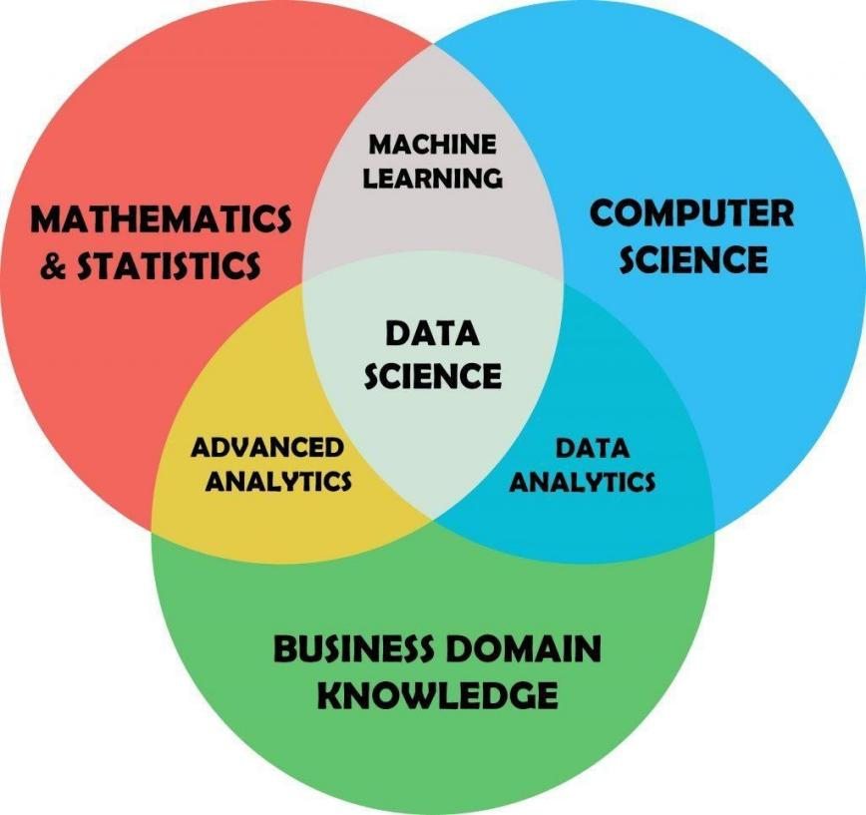
1. Data Analysis: The Pandas library is mainly used for data analysis operations like data cleaning, filtering data, and visualization.
2. Data Science: Pandas is used in data science projects for preprocessing, visualization, and feature engineering.
3. Business Intelligence: Pandas helps in the process of reporting data, visualizing data, and mining data.
4. Scientific Computing: Pandas is widely used in scientific computing purposes, such as data analysis, visualization, and data simulation.
5. Machine Learning: Pandas can be used for data preprocessing, visualization, and evaluation of models.
3.4 Plotly & Altair (Visual Analytics)
What is Matplotlib?
Tools used for visualization make the understanding of observations easier:
• Radar Chart: Helps in visualizing the skills and jobs.
• Bar/Heat Map: Represents the scores for Education, Experience, and Projects.
• Drill-down: Through hovering one can easily understand the feedback comment.
Plotly & Altair are compatible with Streamlit and visualize quickly in the browser without needing any JavaScript code.

3.5 Word Clouds
Definitions and Concepts
Word clouds can also be referred to as tag clouds or wordles. They involve the use of a cloudlike visualization of textual data. Words within a word cloud are arranged based on their frequency of use in the source text; the more frequent a particular word is used, the larger its representation will be.
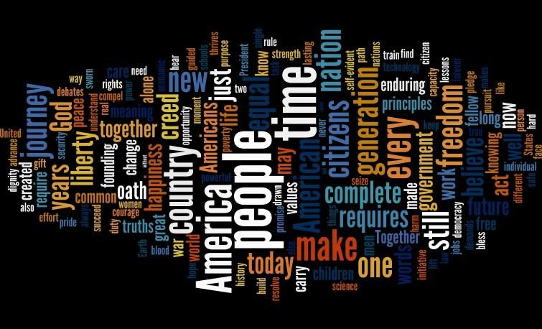

Benefits of Word Clouds
1. Enabling insights generation: Word clouds simplify the process of gaining insights from textual information.
2. Visualization: Word clouds facilitate the visualization of information.
3. Determination of trends: Word clouds help in spotting trends within text information.
4. Ease of generation: Word clouds can be generated relatively easily, even by people who lack knowledge on data analysis and programming.
5. Customizable: Word clouds provide customization options such as font types and colors, shapes, among others.
6. Interactive: Interaction features enable in-depth examination of text information as well as the dissemination of insights.
7. Saves time: Word clouds save time in obtaining insights from text information.

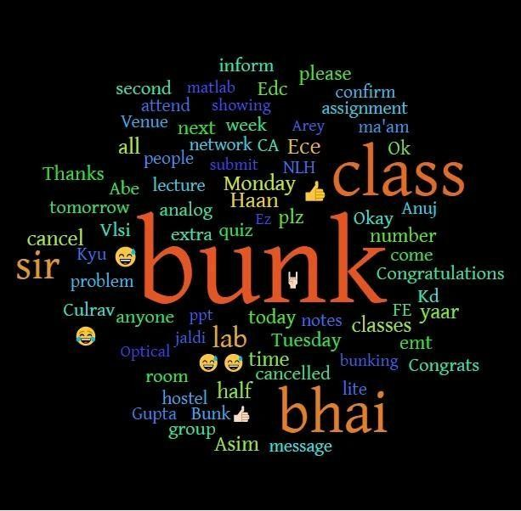

Word Cloud Characteristics

1. Term Frequency: The degree of importance attached to a word in a word cloud is based on how often the word is mentioned.

2. Significance of the word: The significance of a particular word compared to other words is shown by a word cloud.

3. Modification of shape: Word clouds can be shaped into different forms through proper positioning of terms.

4. Coloration: Words in a word cloud can be colored depending on any chosen basis.

5. Interactivity: Word clouds have a number of interactive features among which include display of frequency when the pointer hovers over it and display of associated terms when interacted with.



3.4 Streamlit:

Definition and purpose of use

Streamlit is an open source Python library that is intended to help machine learning engineers and data scientists create visually appealing web applications. This application provides users with an easy way of creating, deploying and sharing data visualizations and data science applications.


Advantages of Streamlit

1. User-friendly APIs: There are accessible user interfaces in Streamlit which allow users to use this platform even without any knowledge of web development.

2. Prototype development: This service helps in developing prototypes for scientific projects to test and implement new ideas faster.

3. Interactive visualizations: Users may choose from such options as graphs, maps, and tables in order to interact with data in real-time mode.

4. Compatibility with ML libraries: Integration with popular libraries like scikit-learn, TensorFlow, and PyTorch is easy with Streamlit which is why deploying and sharing ML models is convenient.

5. Customizing options: Applications created using Streamlit can be customized through layout, theme, color, and font selection.

6. Collaboration: This solution is useful for collaboration purposes as well as sharing data-driven applications among team members.

7. Scalability and deployment: Any data-driven application can be scaled up and deployed on a cloud platform.

8. Open source and free: Streamlit is an open-source application and is free of charge.

9. Problem-solving support community: This software allows users to ask questions about problems and receive advice from other people who use Streamlit for building applications.

10. Data science tools: Libraries and tools can be used for different types of data science and machine learning applications.

Some Key Features of Streamlit:


Streamlit comes with a variety of widgets such as text inputs, drop-down lists, and sliders to allow users to interact with the application.
1. Widgets: It is possible to use various types of interactive widgets such as text boxes, select boxes, and sliders.
2. Visualization and charts: The framework has various options for visualization, such as bar graphs, scatter plots, and heat maps.
3. Machine learning models: Streamlit provides an easy interface for the use of machine learning frameworks and allows one to share models seamlessly.
4. Data importation: Various data manipulation features are available in Streamlit and one can import data from sources such as CSV, JSON, and pandas DataFrames.
5. Deployment: One can deploy applications using Streamlit easily.

Some of the use cases of Streamlit are:
1. Data Science: This type of application requires the use of various data visualization techniques for the generation of machine learning models.
2. Machine Learning: Such an application involves deployment and sharing of models which require visualization.
3. Business Intelligence: For any project related to business intelligence, one needs interactive reports and dashboards.
4. Education: The Streamlit framework can help create interactive lessons and tutorials.
5. Research: All kinds of research activities will require interactive visualization applications.

3.6 OpenAI API (Large-Language-Model Services)

These REST APIs facilitate communication with cutting-edge language models such as GPT-4o, which have capabilities to analyze and generate human language.

Reasons for choosing the proposed stack of technologies

- Semantic resume analysis: Such a technology provides opportunities for recognizing various skills and experiences and other information not available through simple keyword analysis.
- Individual feedback: Through prompt engineering, evaluations can be made to see if a person’s resume meets the necessary criteria for becoming an AI/ML Engineer.
- Generation of interview questions: Multiple questions and their answers can be produced based on someone's profile information.
- Maintenance-free use: Models are updated by OpenAI, and versioning of the API enables smooth switching from one update to another.

3.4 SpaCy and LangChain (NLP and Orchestration)

SpaCy – Natural Language Processing (NLP)

- Tokenizing: Tokenization of the resume into tokens which include words, sentences, and phrases.
- Named Entity Recognition (NER): Extraction of key named entities, namely names, degrees, skills, organizations, locations, and dates from the resumes.
- Part-of-Speech (POS) tagging: Helps in determining the sentence structure and phrases.
- Dependency Parsing: Analysis of the sentences in order to determine relationships and achievements.
- Pre-trained Language Model Pipelines: Use of pre-trained language models such as (en_core_web_sm).

LangChain – Large Language Model (LLM) Task Orchestration

- Prompt Management: Creating, managing, and recycling prompts for evaluation, generation of feedback, and posing of questions.
- LLM Chaining: Combining several tasks performed by different LLMs such as extraction, evaluation, and optimization.
- User Context: The ability to maintain user context across different operations (for example, comparing two resumes for one job position).
- Inter-API Functionality: Ability to use various APIs including OpenAI, HuggingFace, and even a custom one in order to build an orchestration pipeline.
- Prompt Refinement: Automatic re-execution or modification of the prompt if its result is not domain-relevant.

PostgreSQL (Optional Analytics Store)

- Relational database: Open-source relational database management system that is ideal for working with structured data.
- Resume information and user info: Suitable for keeping track of resume data, account creation, progress made in the past, and logging feedback.
- Metrics related to user activity: Can be used to log user metrics, resume submissions, trends in scores, and other user-related metrics.
- Role-level analysis: Ideal for role level analytics such as skill gaps in AI/ML resumes.
- Scalability and reliability: Can handle a lot of structured data efficiently and reliably.
- Integrating with Python: Can easily be integrated with Python using psycopg2

CHAPTER -4

Required Hardware Resources
This section describes the hardware that will be needed to ensure the proper functioning of the AI-Driven Smart Electric Vehicle Charging Station Network Optimization Platform. The mentioned hardware creates conditions for the processing, analysis, ingestion, and visualization of data.

Computer/Laptop Hardware

1) Computer/Laptop
In order to create, test, and monitor the platform, the following piece of hardware will be needed: a computer or laptop with appropriate computing capabilities.
Specifications:
Minimum:
- CPU: Intel Core i5 or equivalent from AMD
- RAM: 8 GB
- Hard Drive: 256 GB SSD
Optimum:
- CPU: Intel Core i7 or higher
- RAM: 16 GB or greater
- Hard Drive: 512 GB SSD

2) Monitor
It will be necessary to have a Full HD screen for creating dashboards and analyzing information, as well as working with the Azure Cloud Infrastructure.
- Resolution: 1920 x 1080

3) Internet Connection
In order to be able to use Azure Cloud Infrastructure, it will be necessary to have an internet connection.

Software Requirements
Operating System
The software has been designed for its development and implementation on:
- Windows 10/11
- Linux (Ubuntu recommended)
- macOS

Programming Language
- Python
Python is used for:
- Data processing
- Data transformation
- Machine learning model creation
- Data analysis
- Dashboard integration

3. Azure Cloud Services
Azure Data Factory (ADF)
Uses of Azure Data Factory (ADF) include:
- Data ingestion
- Pipeline orchestration
- Workflow automation
- ETL process management

Azure Data Lake Storage Gen2 (ADLS)
The role of Azure Data Lake Storage Gen2 is that of a storage layer, with uses in:
- Storage of raw data
- Storage of processed data
- Storage of analytical data sets
- Cloud-based storage management

Azure Databricks
Aure Databricks is utilized for:
- Data cleaning
- Data transformation
- Feature engineering
- Machine learning model training
Big data processing using Apache Spark

Azure Synapse Analytics
Ues of Azure Synapse Analytics include:
- Data warehousing
- Analytical queries processing
- Business intelligence reporting
- Processing of processed data sets

Power BI
Uses of Power BI include:
- Development of dashboards
- Data visualization
- Performance monitoring
- Business intelligence reporting

4. Libraries & Frameworks
Data Processing
- Pandas
- Numpy
- PySpark
Machine Learning
- Scikit Learn
Data Visualization
- Matplotlib
- PowerBI
Dashboard Building
- Streamlit

5. Database & Data Storage
Azure Data Lake Storage Gen2
Used for storing:
- Charging session data
- Weather data
- Traffic data
- Station data
- Analyzed data sets

Azure Synapse Analytics
Used for:
- Structured data analysis storage
- Data warehousing
- Query performance optimization

6. Development Tools
Tools used to develop and manage the project:
- Visual Studio Code
- Jupyter Notebook
- Azure Portal
- Azure Databricks Workspace
- GitHub

Additional Requirements
1. Data Storage
Data storage functionality is crucial for implementing the system, including:
- Charging session history
- Traffic information
- Weather data
- Machine learning data sets
- Analyzed results
- Predictions

2. Computing Resources
In order to perform training tasks and process large amounts of data, adequate computing power is needed, namely:
- Multi-core CPUs
- Increased memory
- Spark cluster on Azure Databricks
- Cloud-based computing service

3. Internet Connection
An internet connection is necessary for:
- Using Azure services
- Designing a pipeline
- Data transfer operations
- Monitoring through a dashboard
- Managing cloud infrastructure
4. Security Needs
Since this system will deal with current operating data from the charging networks, certain security needs should be met, namely:
- User authentication and authorization
- Role-based access control (RBAC)
- Data encryption both in transit and at rest
- Secure Azure Storage access
- Pipeline auditing and monitoring
- Data access management using Azure services
5. Web Browser
Accessing the system and its components using web browsers will be done using typical browser software, namely:
- Google Chrome
- Microsoft Edge
- Mozilla Firefox
- Safari

CHAPTER 5

DATA FLOW DIAGRAM
- Requirements Understanding (Business Understanding)

The objective that will be set in this phase is related to the development of an AI-based Smart Electric Vehicle (EV) Charging Network Optimization Platform. The system will be designed to analyze data associated with the charging network, make forecasts about the occupancy rates, calculate the waiting time, detect any overloads, and derive some insights.
Key Tasks:
- Identify issues related to congestion at charging stations and its influence on the effective use of resources.
- Analyze the factors affecting charging demands like weather conditions, time for charging, traffic situations, availability of the stations, and other parameters.
- Determine the business objectives concerning occupancy prediction, calculation of waiting time, and overload detection.
- Define requirements to the charging network analysis.
- Choose suitable approaches for machine learning and cloud computing.
- Describe stakeholder needs.

2. Data Collection (Data Extraction)
In this step, the intention is to extract information related to charging stations in order to process it. Activities involved in doing that are as follows:
- Obtaining data related to charging sessions of electric vehicles.
- Gathering data specific to individual stations.
- Extracting information about traffic patterns.
- Harvesting information about weather conditions affecting the demand for charging stations.
- Obtaining information about energy consumption and duration of charging sessions.
- Putting the data in Azure Data Lake Storage in Bronze layer.
- Managing data extraction using data pipelines in Azure Data Factory.
Sources of Data:
- Charging Sessions Data
- Station Data
- Traffic Data
- Weather Data
- Energy Consumption Data
- Charging Sessions Duration Data
3. Data Processing (Data Preparation & Cleansing)

This step assumes the transformation of the unstructured data collected regarding charging stations to a form of structured dataset which can be analyzed and utilized in machine learning models. These include:
- Data validation and cleaning.
- Handling problems like missing values, duplicates, inconsistencies, etc.
- Converting the format of the data set in order to have homogeneous data.
- Engineering features for further analysis and applying required transformation.
- Integration of different datasets coming from stations, traffic and weather.
- Processing data in Azure Databricks using PySpark.
- Creating datasets in the Silver Layer.
- Creating datasets in the Gold Layer.

4. Machine Learning Models Application (Modeling)
Objective and Scope
Machine learning models are used to examine dynamics of the charging network and make predictions about those dynamics based on the examination process.
Main activities
- Developing models of the charging network based on charging network database information, leveraging machine learning algorithms.
- Developing predictive models and evaluating them.
- Improving model performance through feature engineering.
- Evaluating model performance.

Machine learning models used
- Occupancy Levels Prediction Model
- Waiting Time Prediction Model
- Overload Prediction Model

Roles of the models
- Forecasting occupancy levels of charging stations.
- Forecasting waiting time at charging stations.
- Discovering potential overload situations.

5. Analysis, Prediction, and Evaluation
This chapter describes the analysis techniques that were used on the collected data to draw conclusions. The main analytical tasks include:
- Forecasting the occupancy of charging stations
- Prediction of waiting time
- Identification of overloaded stations
- Analysis of trends in charging station use
- Analysis of the influence of traffic on charging station use
- Analysis of the influence of the weather on charging station use
- Analysis of the accuracy of prediction
- Building datasets for subsequent business analysis
Prediction Analytics Provided:
- Station Performance Analytics
- Station Demand Analytics
- Traffic Influence Analytics
- Weather Influence Analytics
- Trend Analysis

6. Data Warehousing & Business Intelligence
After carrying out data processing and analysis, the analytical data sets are stored in the data warehouse for business intelligence processes. Tasks include:
• Uploading the analytical data sets into Azure Synapse Analytics.
• Managing the analytical data warehouse.
• Designing data structure for improved reports.
• Executing complex queries and analyses.
• Accessing central business intelligence data sets.

7. Visualization and Dashboards Reporting
The main goal behind the creation of the dashboards is to make the charging process observable at any point in time and create predictive visualization.
Important Activities:
- Develop the dashboard with Power BI and Streamlit software.
- Create visualizations of charging demand trends.
- Create visualizations of occupancy and waiting time.
- Track KPIs associated with the charging stations.
- Determine the effect that traffic and weather have on the charging demands.
- Report on all of the above.
Dashboards to be Created:
- Occupancy Rate Dashboard
- Waiting Time Dashboard
- Overload Dashboard
- Charging Demands Dashboard

8. Implementation
This phase will focus on the implementation of a full-fledged EV Charging Network Optimization Platform. The major actions involved include:
- Implementation of the Azure Data Factory pipelines to ingest data.
- Control of cloud storage using Azure Data Lake Storage Gen2.
- Processing of data with Azure Databricks.
- Warehousing of data with Azure Synapse Analytics.
- Reporting and visualization using Power BI dashboards/reports.
- Data pipeline monitoring for maximum efficiency.
- Regular update of the machine learning model for accuracy.
- Ensuring platform scalability, reliability, and security.
- Offering a data-driven intelligence platform for optimizing the EV charging network.

CHAPTER 6
RESULTS & DISCUSSION
1. Home Page of the AI-Based Intelligent EV Charging Network Optimization System
The home page is a dashboard of the project (AI-Based Intelligent EV Charging Network Optimization System). The information provided by the home page includes the status of the charging station network, availability, occupancy rate, estimated waiting time, and advice.
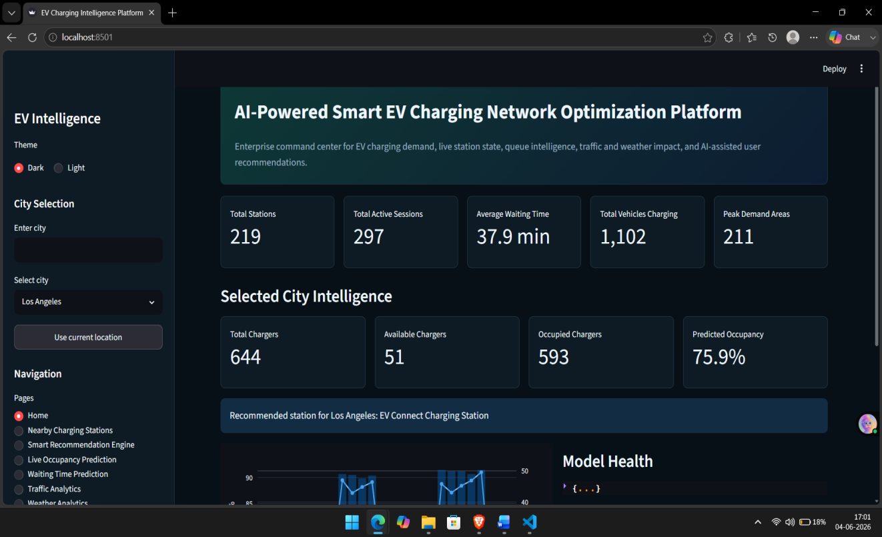
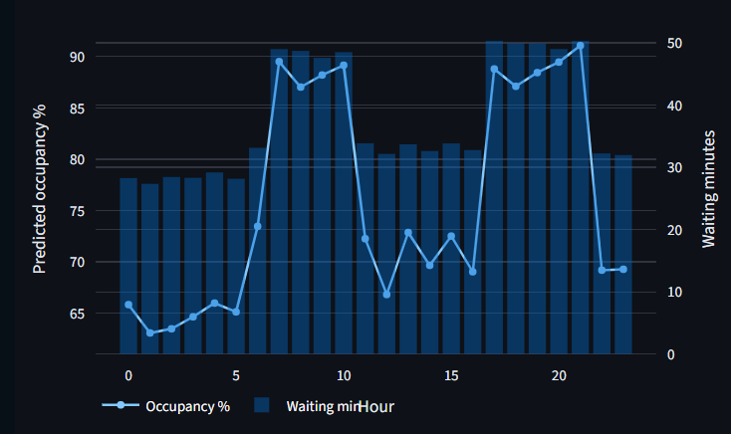
Information Displayed on the Home Page:
- Number of charging stations
- Number of charging sessions ongoing
- Average waiting time
- Number of cars currently being charged
- Demand periods
- Occupancy rate
- Number of free and busy charging stations
- The perfect charging station
Dashboards are built by using Streamlit tools and provide professional and easy-to-use interfaces. A person can pick a city of choice, look for information about charging and switch to other sections through the menu.

2. Proximity Charging Station
This module allows people to find the closest charging stations and check their availability. Information includes:
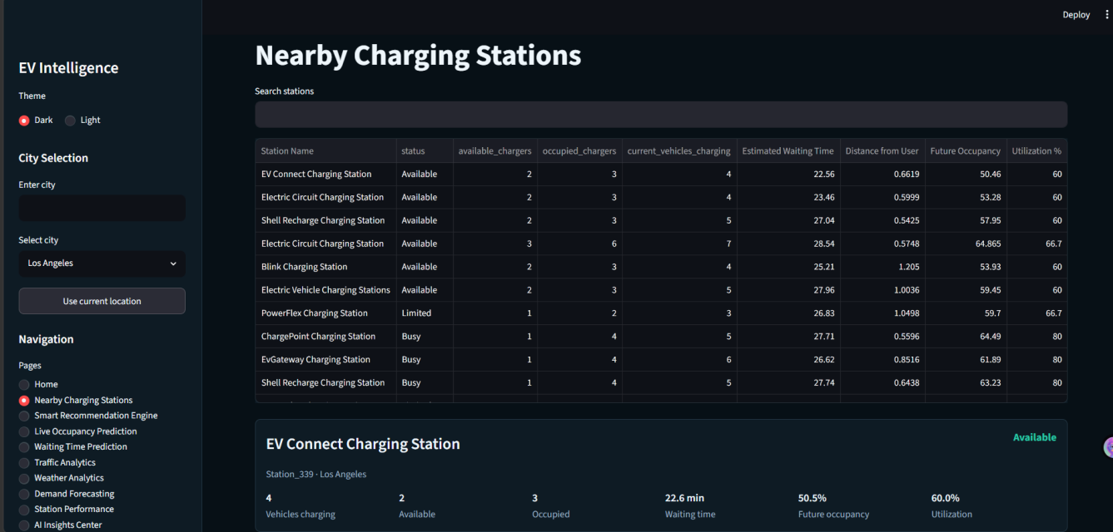
- Name of the Charging Station
- Status (Available, Occupied, or Partially Occupied)
- Available Charging Points
- Occupied Charging Points
- Current Number of Vehicles Charging
- Estimated Wait Time
- Distance from the User
- Predicted Future Availability
Users are enabled to find the most appropriate charging station based on the distance, availability, and estimated wait time for parking purposes.

3. Intelligent Recommendation System
The intelligent recommendation system uses predictive analysis techniques to determine the best charging station based on various parameters such as
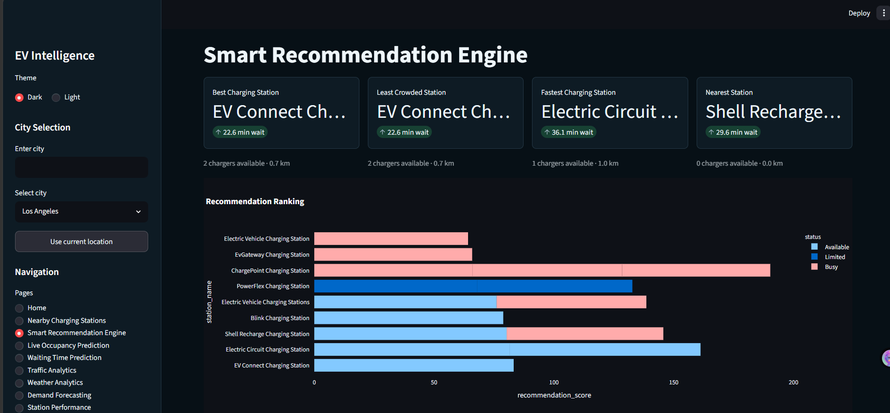
- Availability of charger
- Estimated waiting time
- Proximity to user
- Station occupancy prediction
- Usage rate of station
- Station status

These parameters help to identify:
- Most optimal charging station
- Less crowded charging station
- Best charging station in terms of speed
- Closest charging station
Moreover, there is also a recommendation ranking chart that compares different stations based on their recommendation scores.
4. Live Occupancy Prediction
In this module, predictions of charging stations’ occupancy rates at different hours of the day are made through machine learning models. Predictive analytics for occupancy rate provides:
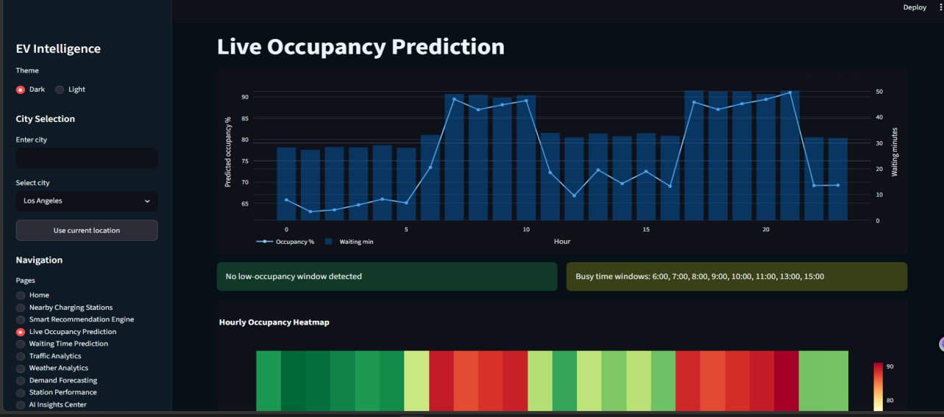
Analyses include:
- hour-by-hour occupancy prediction,
- waiting time prediction,
- busy period detection,
- occupancy rate trend analysis,
- occupancy rate monitoring.
With the help of these visualizations, one can look into fluctuations in demand for charging and recognize busy periods. Therefore, they will allow for better control of charging station occupancy.
5. Waiting Time Forecasting Analysis
The Waiting Time Prediction component calculates the estimated waiting time periods at the charging station locations.
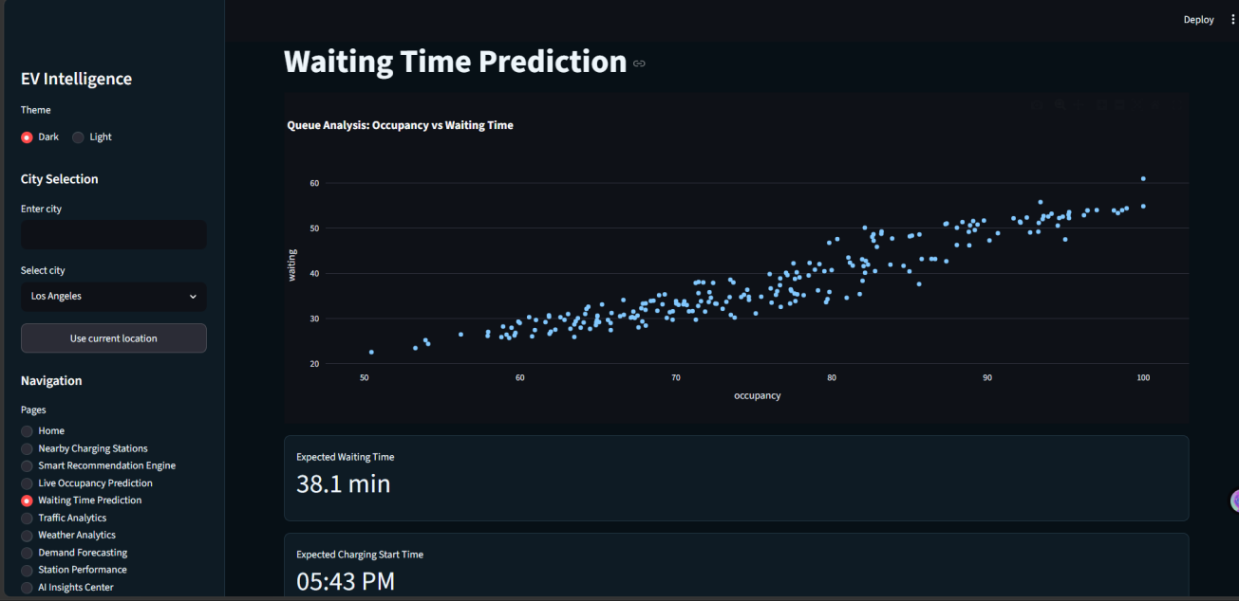
The outcome of the model will be as follows:
- Waiting Time Prediction
- Occupancy-Waiting Time Analysis
- Queuing Behaviors Charts
- Waiting Time Prediction Using Demand
- Efficiency Analysis of the Charging Station Network

From the analysis, it will be shown that there is a relationship between occupancy and waiting time. This can help people determine which charging station to use.

6. Traffic Analysis:
The traffic situation plays an important role in the need for charging services. This component analyzes the traffic situation and how it impacts the effectiveness of the network charging system.
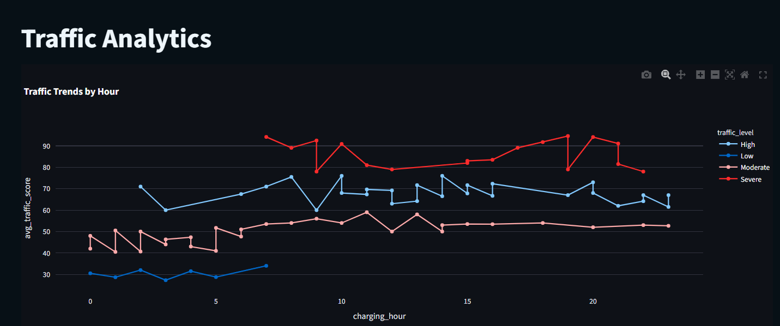
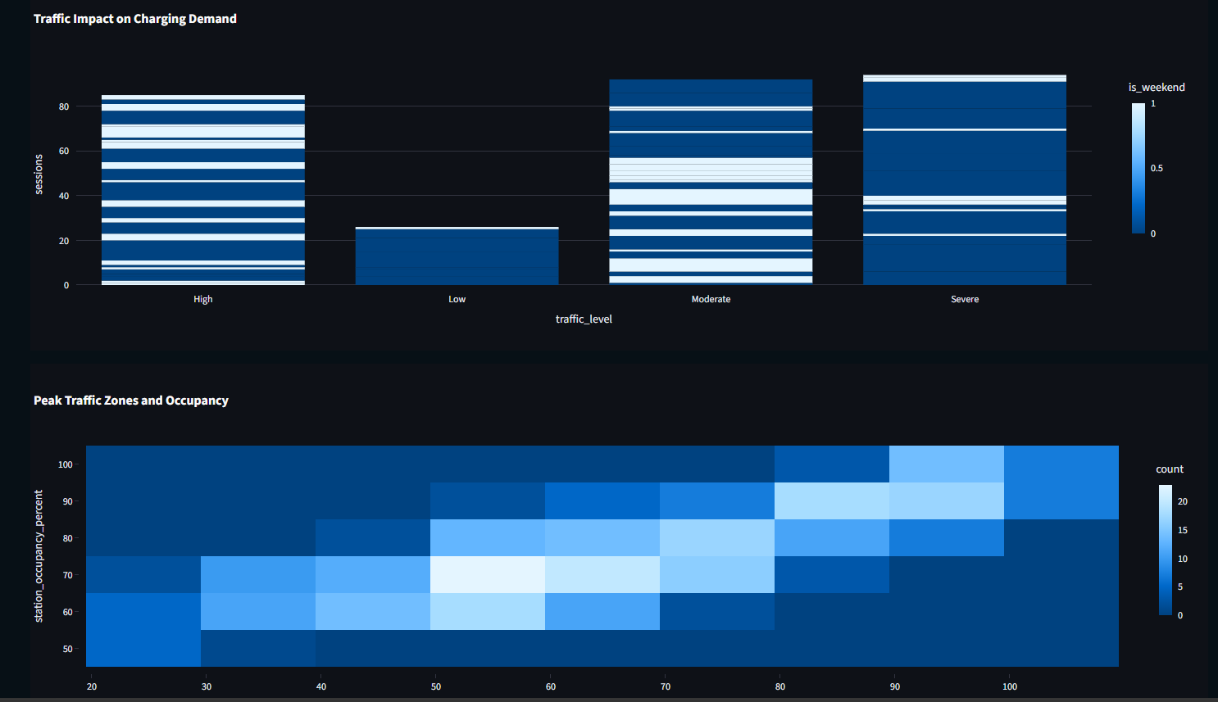
These include:
- Hourly Trends of Traffic
- Effects of Traffic on Charging Demands
- High-Traffic Area Identification
- Station Occupancy under High-Traffic Conditions
- Analysis of Traffic Situation
From the analysis above, there is a correlation between traffic trends and station occupancies hence making traffic trends data important for demands prediction.
7. Weather Analytics
Climate plays an important role in affecting electric vehicle (EV) charging demand and its trends.
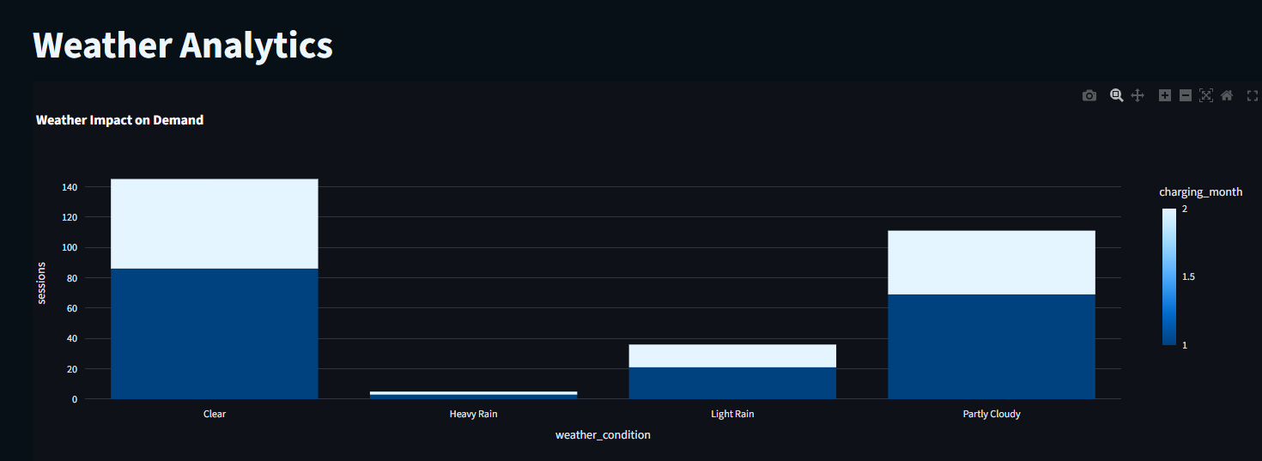
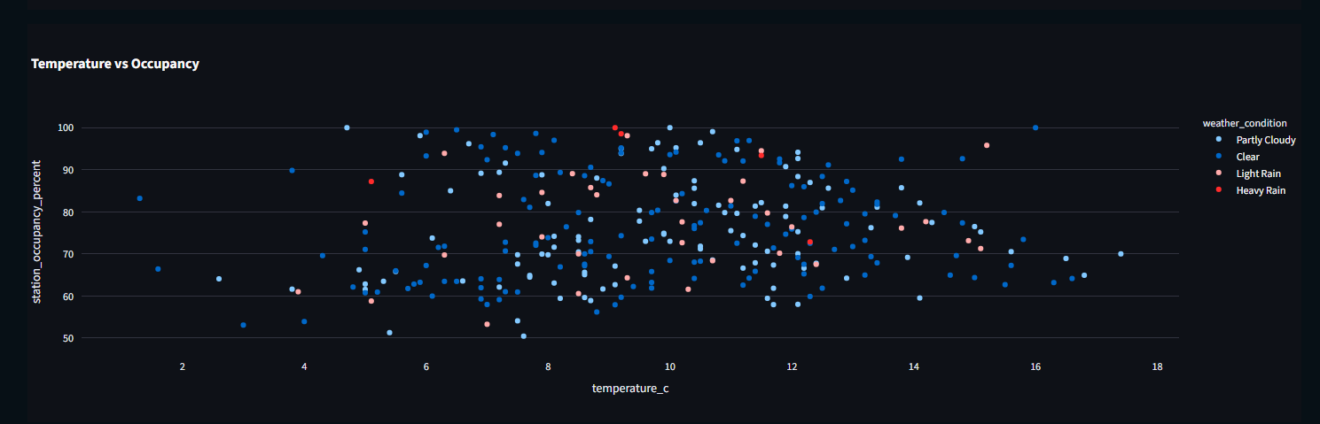
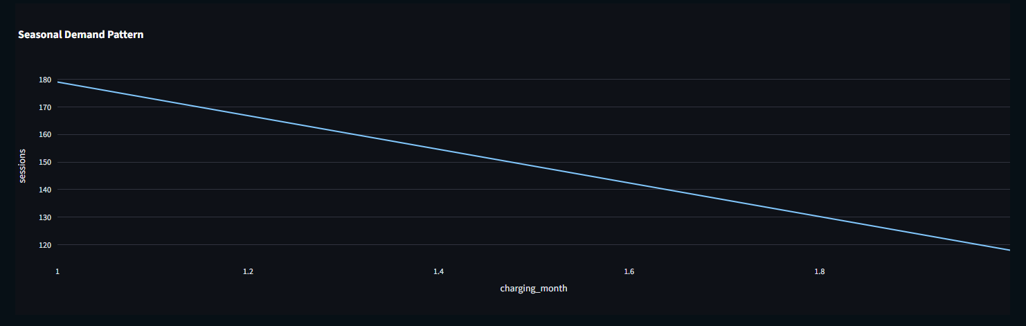
The Weather Analytics module consists of the following:
- Climate’s effect on charging demand
- Temperature against occupancy analysis
- Seasonal demands analysis
- Usage patterns by climate
- Charging demand analysis based on the weather
These analytics help network providers understand how climate influences the use of charging stations.

8. Demand Forecasting
Forecasting of demands is used to plan for the future by estimating the needs of the charging network.
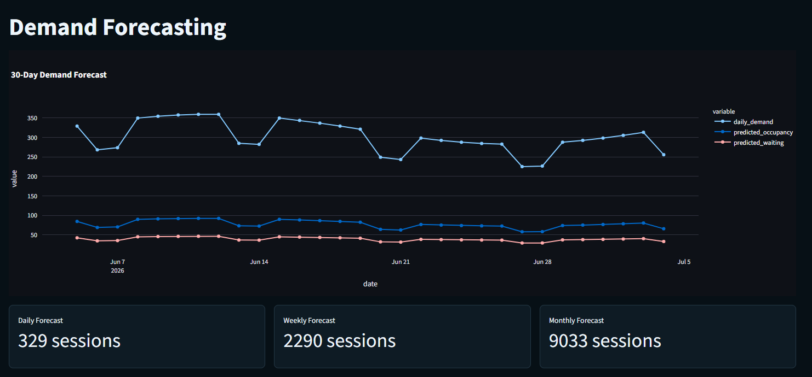
The output of the forecasting model includes:
- Daily Demand Forecast
- Weekly Demand Forecast
- Monthly Demand Forecast
- Estimated Occupancy Level
- Wait Time Estimates
The forecast results assist stakeholders in estimating their expected future demand.

9. Station Performance Analysis
The station performance analysis module helps in assessing how well each station is functioning. The output provided by this module includes the following items:
- Best Performing Stations
- Worst Performing Stations
- Usage Patterns Analysis
- Energy Consumption Analysis
- Station Performance Analysis
- Overload Monitoring
Through this process, one will be able to ascertain which are the best and worst performing stations.

10. AI Insights Centre
The AI Insights Centre provides intelligent insights through predictive analytics, which is the output of the AI engine as follows:
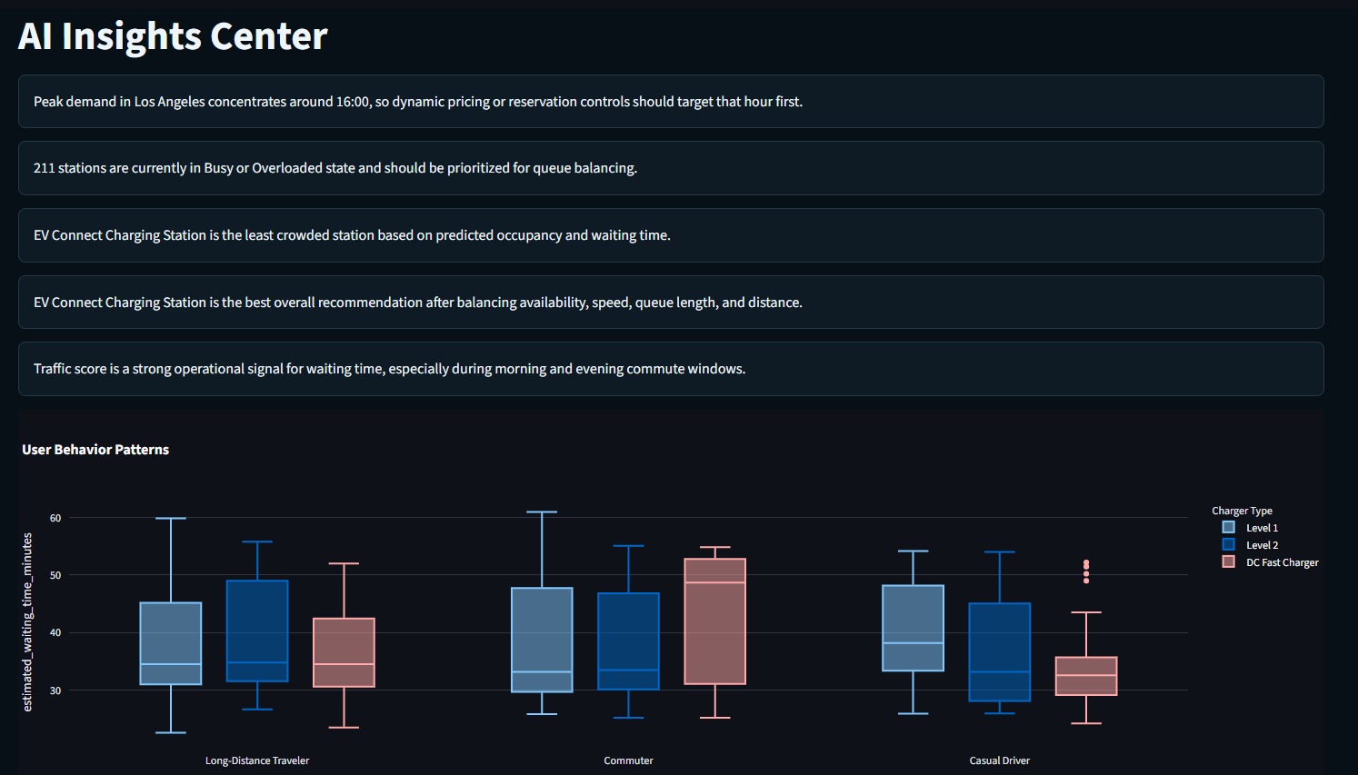
- Peak Demand Identification
- Queuing Balance Suggestions
- Ideal Station Suggestions
- Lessons on Effect of Traffic
- Optimal Occupancy Suggestions
- Lessons on Performance
This will aid the operator in decision making based on lessons from this study and improve network efficiency.

11. Charging Stations Map Visualization
Charging stations map visualization can be created through the Map Module. The map provides information about:
• Charging stations locations
• Geographic spread of charging stations
• Density of charging stations
• Availability of charging services regionally
• Navigation within the map
This makes it possible for the user to find out where the closest charging stations are located and determine charging station availability regionally.

Discussion
Through the application of AI-Powered Smart Electric Vehicle (EV) Charging Network Optimization Platform, it is evident how data engineering, machine learning, predictive analytics, and business intelligence help optimize the operation of the electric vehicle charging network. These processes involve use of data, such as charge sessions, traffic information, weather conditions, station usage, among others, to derive insights.

From empirical studies, it has been observed that machine learning provides precise prediction in terms of station occupancy rates, wait time, and charging needs. Moreover, Smart Recommendation Engine provides recommendations on best station choices through different operational aspects. Through the integration of traffic and weather analysis into the predictive processes, more aspects are involved.
The integration of these features into one single platform helps enhance station usage, lower waiting time, increase efficiency, and ultimately improve the intelligence of the electric vehicle charging network.

CHAPTER – 8

CONCLUSION
AI-Powered Smart EV Charging Network Optimization Platform is the name given to the innovative data-driven solution created to solve new problems arising in terms of EV charging network infrastructure optimization. With more and more countries switching to using electric vehicles, factors like efficient utilization of charging stations, reduction in the waiting time, intelligent demand forecasting, and optimal charging recommendations have become necessary. This is the solution that attempts to combine technologies of Data Engineering, Cloud Computing, Artificial Intelligence, and Data Analytics to create a revolutionary platform improving EV charging network infrastructure.
The AI-Powered Smart EV Charging Network Optimization Platform uses Microsoft Azure Services that enable setting up a state-of-the-art cloud infrastructure. For instance, the solution uses ADF (Data Factory) and ADLS Gen2 (Data Lake Storage), which can be used for data collection and storage, respectively. In addition, Azure Databricks can be used for processing data and machine learning, while Azure Synapse Analytics allows processing big data. Therefore, all technologies mentioned above facilitate the process of data collection, processing, transformation, and analysis.
It is the advanced analytics, together with the application of machine learning algorithms and models, that enables conversion of data on charging station, traffic, weather, and utilization into insights that are critical for doing business. Numerous intelligent functionalities were incorporated into the system including such elements as Live Occupancy Prediction, Waiting Time Prediction, Demand Forecasting, Smart Station Recommendation, Traffic Impact Assessment, Weather Forecasting & Analysis, Performance Monitoring, AI-Based Insights Generation, and Geographical Visualization via Interactive Maps. All these functionalities will be helpful for both users in choosing charging stations and charging station operators in resource optimization.
Another important feature of the project is providing operation intelligence on a real-time basis. Specifically, the platform analyses availability and occupancy levels, charger utilization, traffic, weather, etc. as a result of which predictive recommendations can be generated. It will enable minimizing congestion, maximizing charging efficiency, and increasing customers' satisfaction.
Incorporating machine learning, visualizations, and big data into practices in solving transportation and energy issues should also be acknowledged as an achievement of the project. Indeed, dashboards and interactive visualization help stakeholders get insights regarding charging networks infrastructure performance, demand, bottlenecks, etc. In turn, decisions based on analyzed data can be made by charging stations operators, city managers, and users.
However, despite all the benefits which have already been outlined, several problems remain to be solved. These problems consist of data dependence, real-time data accessibility, data analysis and forecasting precision, and scalability. Several improvements can be introduced; they may comprise such aspects as IoT devices implementation, renewables optimization, dynamic pricing mechanism application, mobile applications creation, machine learning algorithms development, among others.
As for overall performance of the developed intelligent EV charging station system, it is considered to be an excellent contribution into transportation, sustainability, and smart cities development. In particular, it can be regarded as a scalable solution implemented due to application of machine learning and other advanced technologies like Azure Cloud Computing and so forth.

References:

Project Teacher
- https://www.google.com/
- https://www.kaggle.com/
- Chatgpt
- OpenAI API & Documentation
- Streamlit Documentataion
- US problems

SIMIARITY REPORT


AI PLAG REPORT


